Jackfruit/Level 3 Problem:
Figure shows a Figee floating crane with a lemniscate boom configuration, and Fig. P11.13b shows a schematic diagram of the crane with dimensions given in the legend. The lifting capacity is 16 T (where 1 T = 1 metric ton = 1 000 kg) including the grab, which is about 10 T. The maximum outreach is 30 m, which corresponds to the position θ2 = 49◦. The minimum outreach is 10.5 m at θ2 = 132◦. For the maximum outreach posture and a grab load of 10 T (under standard gravity), find the bearing reactions at A, B, O2, and O4, as well as the torque, T12, at O2. Notice that the photograph shows a counterweight on link 2; neglect this weight and also the weights of the members.
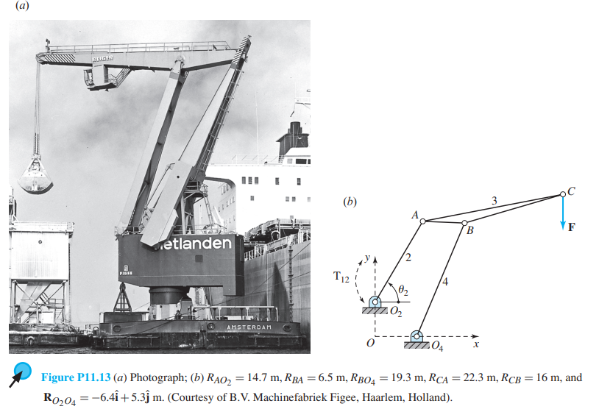

Configuration Diagram: (Units in metres or Newtons)
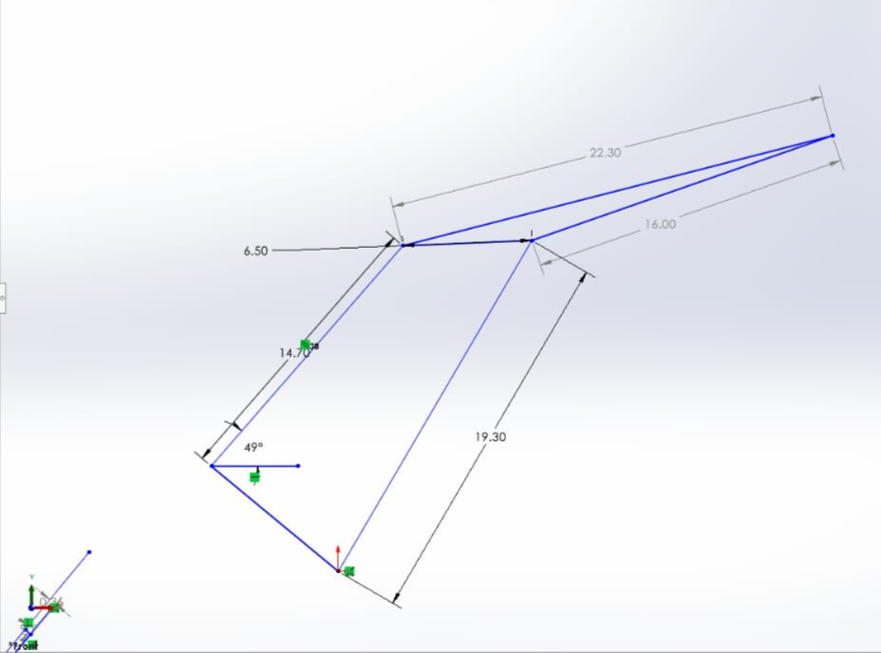
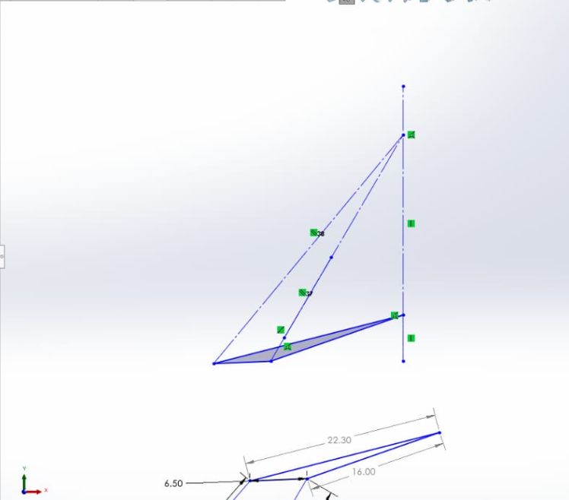
Line of Action :
Static Force Analysis:
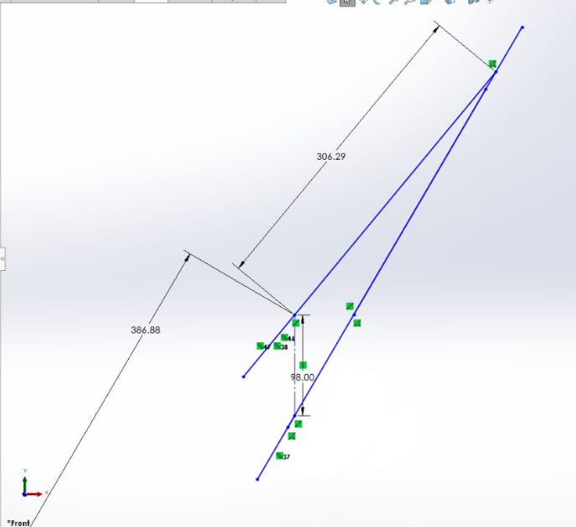
Force = 306.29N

Torque Analysis:
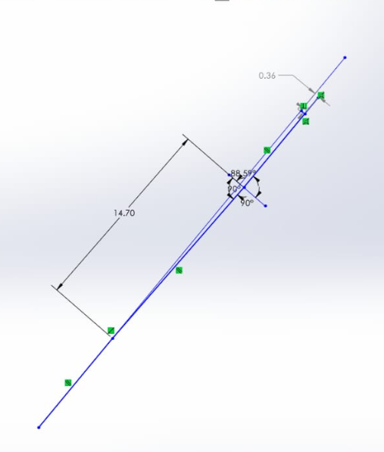
Perpendicular distance = 0.36m PTO……

Torque Calculations :
T = F * h
T = 306.29 * 0.36
Torque = 110.2644 N-m

